IRB Approved at the Protocol Level

Jan 09, 2024

20235584

#39242237.1

**Research Study On**

**Breakthrough Parenting Curriculum:**

***Navigating Trauma Across Generations***

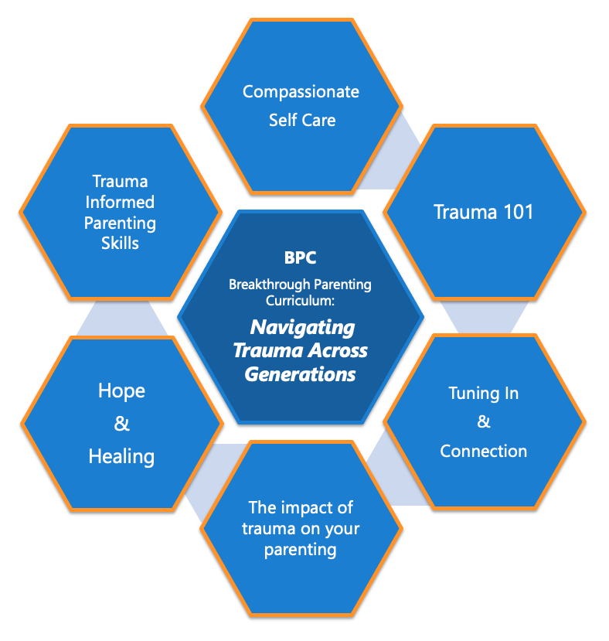

*Caring for a child or youth who has experienced trauma can be challenging and difficult, especially when you may have had similar traumatic experiences. Unresolved trauma can negatively impact parenting and interfere with healthy decision-making.*

*The experience of trauma can lead to traumatic stress reactions that can be confusing, frustrating, and overwhelming for both parents and children. Traumatic stress reactions and other responses to trauma can cause children to behave in ways that may baffle you. Their relationship with you, with other adults, and even with their peers may feel shaky or unpredictable, and usual approaches to parenting may not work with them.*

***Trauma Informed Parenting can make all the difference!***

**BPC** is a free 10 weeklong course for parents who have been (or are at risk of) being involved with the child welfare system. It educates parents about the impact of trauma on themselves and their children, while providing information, skills and strategies for understanding, healing, hope and growth.

People who participate in this study will receive BPC Immediately or be asked to wait approximately 6 months before receiving the BPC. Participants will ask be asked to complete surveys during the course and 6-months after the course. Participants will receive up to $100 for their participation.

If you are interested in participating please speak with your provider or enter your information via this link:

<https://redcap.med.uvm.edu/surveys/?s=3K4XPFKNTYYFDJ3E>